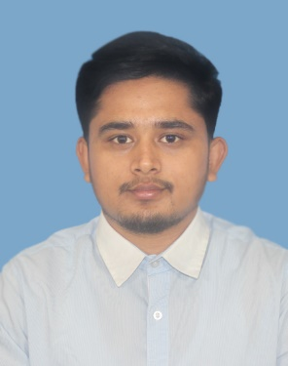**MD NAFIJUL HOQ**

**+8801733-256209**

[nafijulhaque118@gmail.com](mailto:nafijulhaque118@gmail.com)

Bashundhara R/A, Dhaka 1229

**Carrier Objective**

I am currently in the final semester of my Bachelor of Science in Computer Science & Engineering (BSc CSE) at the American International University of Bangladesh (AIUB), with a major in Software Engineering. As I near the end of my degree, I’m looking for possibilities in the IT field to put my skills to use improve my programming abilities. I am dedicated to further expanding my knowledge and skills in a variety of applications and technology, ensuring that I am well-prepared for a successful career in the industry.

**Skills Summary**

* Proficient in multiple programming languages (C/C++, Java, Python).
* Experienced in Database Management System, MySQL server.
* Experienced in HTML5, CSS3.
* Experienced in Microsoft Office.
* Proficient in Linux Command.
* Leadership.
* Teamwork.
* Communication.

**Projects**

1. **Hospital Management System (HMS)**

* It is a web application using HTML, PHP, CSS, JavaScript, MySQL.

<https://github.com/MdNafijulHoq/Hospital_Management_System>

1. **Flood Affected City**

* A Graphical view of a Bridge side City using C++ OpenGL.

<https://github.com/MdNafijulHoq/Flood-Affected-City--ComputerGraphics-Project>

1. **Bank Management System**

* Using basic Java. It is a console application based on the knowledge of Object-Oriented Programming-1(Java) Course.

<https://github.com/MdNafijulHoq/Bank_Management_System>

1. **Online Bank Management System**

* Using SQL Query

https://github.com/MdNafijulHoq/Online-Bank-Management--DatabaseProject-SQL-

**Academic Qualification**

* **BSc in Computer Science and Engineering (CSE).**

American International University-Bangladesh (AIUB).

CGPA: 3.58 out of 4.00. (Cumulative 3rd year)

Passing Year: 2023 (Expected date of Completion)

* **Higher Secondary Certificate (HSC)**

Group: Science

College: Holy Land College, Dinajpur.

GPA: 5.00 out of 5.00.

Passing Year: 2019.

* **Secondary School Certificates (SSC)**

Group: Science

School: Purba Sadipur High School, Doshmile, Dinajpur.

GPA: 4.55 out of 5.00

Passing Year: 2017.

**Portfolio**



https://www.linkedin.com/in/nafijul-haque-411b94262/

https://github.com/MdNafijulHoq

**References**

|  |  |
| --- | --- |
| **DR M M MANJURUL ISLAM****Assistant Professor, Computer Science, AIUB****Email: manjurul@aiub.edu** | **S M ABDULLAH SHAFI****Lecturer, Computer Science, AIUB** **Email: shafi@aiub.edu** |